Work sheet

*Natural acid-base indicator’s*

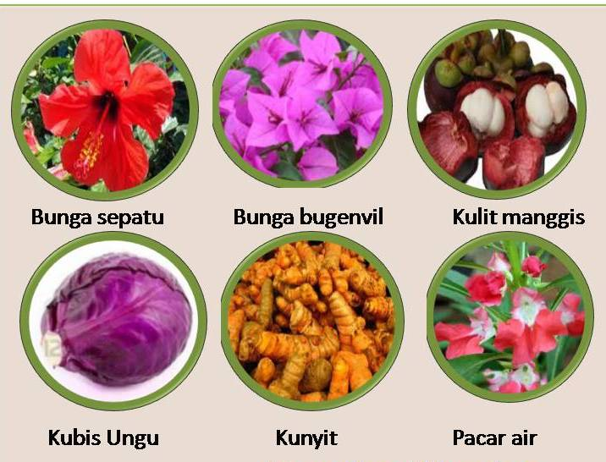

Created by : Tasmuri (4001413024)

NAME oF GROUP : …………………………………………..............................……….....

……………………………………………………………………………….…………………….....................................................................................................................................................................................................................................................................

CLASS : ………………………………………………………………………………..

Natural Acid-Base Indicators

1. Purpose

* Students can differentiate between acids and bases using natural indicators

1. Tools and Materials
2. Materials

* Citrus solution
* Soap solution
* Baking powder
* Vinegar
* Water
* Indicator 1 (Hibiscus flower’s solution)
* Indicator 2 (Turmeric)

1. Tools

* Tablespoons
* Cups

1. What you will do
2. Prepare four cups
3. Place one tablespoons of citrus solution in first cup
4. Place two tablespoons of soap solution in second cup
5. Place two tablespoons of baking powder in third cup
6. Place one tablespoons of vinegar in fourth cup
7. Place two tablespoons of water in fifth cup
8. Add 3-5 molasses indicator 1 to each
9. Observe color changes
10. Do the same step for indicator 2

Observation table

Indicator 1

|  |  |  |  |
| --- | --- | --- | --- |
| No | Solution | Color changes | |
| Before | After |
| 1 | Citrus solution |  |  |
| 2 | Soap solution |  |  |
| 3 | Baking powder |  |  |
| 4 | Vinegar |  |  |

Indicator 2

|  |  |  |  |
| --- | --- | --- | --- |
| No | Solution | Color changes | |
| Before | After |
| 1 | Citrus solution |  |  |
| 2 | Soap solution |  |  |
| 3 | Baking powder |  |  |
| 4 | Vinegar |  |  |

Question

1. Which one solution is acid or base?

Answer: ………………………………………………………………………………………………………………………………………………………………………………………………………………………………………………………………………………………………………………………………………………………………

1. Why does hibiscus and turmeric can be used as an indicator?

Answer: ………………………………………………………………………………………………………………………………………………………………………………………………………………………………………………………………………………………………………………………………………………………………

1. Why does the indicator change color when added to citrus solution, soap solution, baking powder, vinegar?

Answer: ………………………………………………………………………………………………………………………………………………………………………………………………………………………………………………………………………………………………………………………………………………………………